**POWER BI ASSIGNMENT-2**

**Use Case -** Design dashboard with basic set of Visualizations

**Source –** Sky Transport

Q1. Develop a dashboard to show top level brief overview of Sky Transport

**Requirement**

1. KPI for Total Miles, Revenue, Cost

Step-1. Since there is no target value in the data, I have used card visualization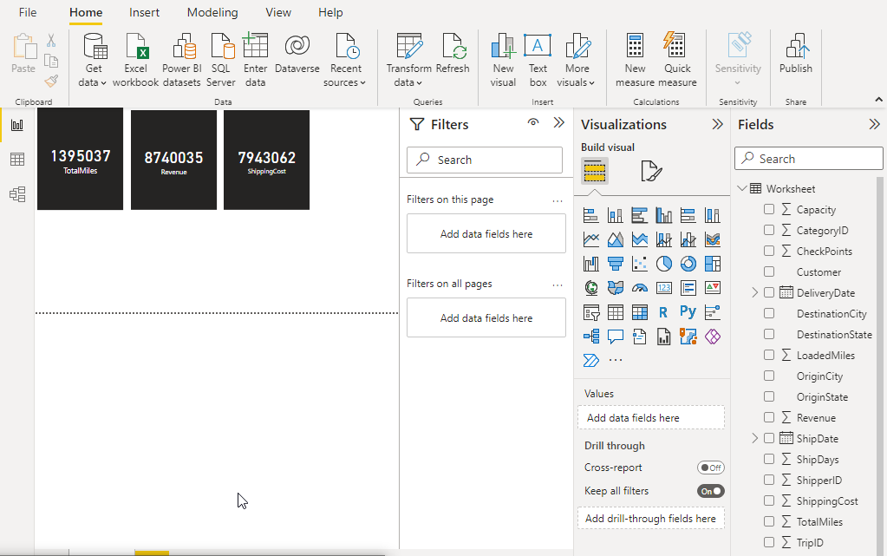

1. Revenue Vs Miles by Shipping State

Step-2. By Using Clustered Bar Chart, I have created created visualization.

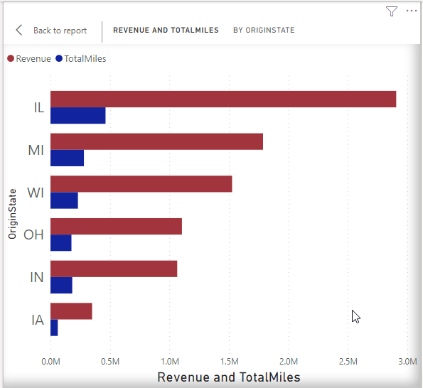

1. Revenue Vs Miles by Shipping City.

Step-3. By using Clustered Column Chart, I have created Visualization.

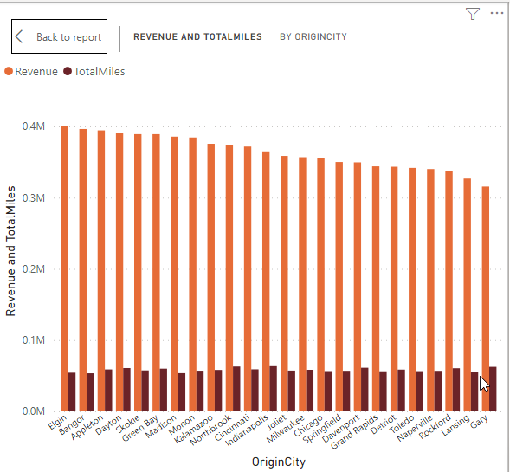

1. Total Trips Vs Trips by Trip Types

Step-4. By using Donut chart, I have created Visualization.

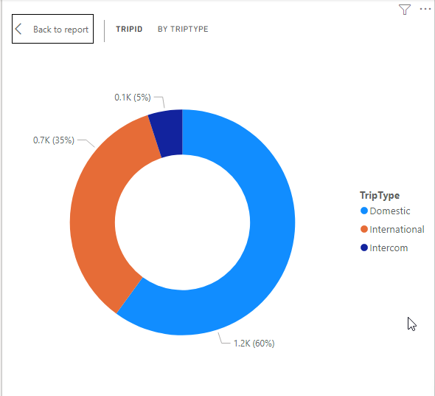

1. % of Trips by Shipping State

Step-5. By using Pic chart, I have created Visualization.

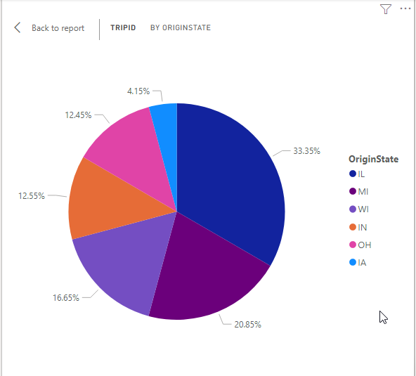

1. Revenue Miles Vs Total Miles

Step-6. By using Donut Chart, I have created Visualization.

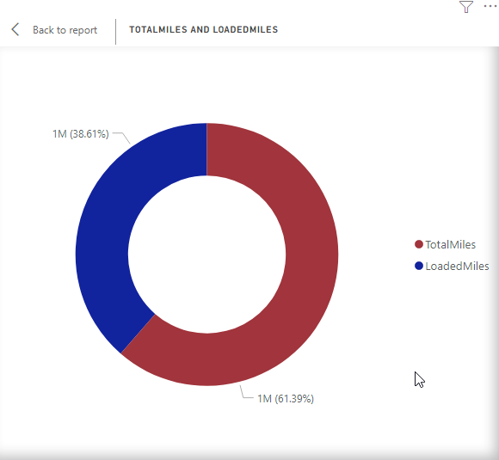

Q3. Save this Power BI file with the name Trip Analysis.

